**IRC Board meeting minutes 2019-03-11**

Attending: Andrew Purdie, Doug Stemmler, Tracy Barta, John Baker, Willie Black, John Murphy, Jason MacLean, Larry Bechtel, Liz Kryder Reid (via speaker phone).

Welcome to Larry Bechtel, new board member and a Masters representative.

**Voted to approve the minutes of the Jan 14, 2019 board meeting.**

**Treasurer’s Report**

Financial reports of 2018 show a profit.

The 2019 proposed budget was approved by email.

The 990 tax forms will not be done by April 15th.

The restricted funds have been moved to a Scwab account. They will not qualify as an “endowment fund” until they total 250K. Restricted fund balance went up by the same 23K that club cash decreased. There are two restricted accounts, one for the Fleet, and one for the Audrey Lupton Scholarship.

2019 Budget predicts approximately 10K in profits, and did not anticipate the grant. Depreciation is about $30K per year. Depreciation will go up over the next 15 years (about 12K/year)

We raised more money than usual in 2018, thru fund raising, and we had a good cash influx due to rise in Juniors’ programs fees.

Sports Corp Grant of 180,000

$183,000 is the estimated cost of the starting platforms. This grant is specifically for replacement of starting platforms. IRC needs to raise $30,000. The grant is 120K up front, then our 30K will be matched when we raise it. The last $3,000 will also be IRC cost. Eric Johnson is working on raising the $30,000.

**Executive Director’s report**

The coffer dam is actively under re-construction and should be done by April 27.

The starting docs should be delivered no later than May 17th!

We are using a new payroll processor (in transition).

Juniors and Masters are all on TeamSnap for communications, now.

We have collected all but four rack fees for 2019.

Board wants to know what it will cost to get the finish tower up to standards.

Programs

There is a new sculling class for Masters age group on Mondays (taught by Jen Floyd).

The increase in program fees seems to be working

IRC needs the cost (fee use) breakdown on our web site.

TeamSnap is updating our IRC web site. See the ED report (attached) for social media statistics.

The annual report for 2018 needs to be on the IRC web site.

We are getting impact data from Visit Indy for our High School event.

**2019 Events**

High School Sprints

NCAA National Championships

Indy Summer Sprints

Head of the Eagle

High school event will use the old starting docks.

IRC needs to thank those influential in us getting the grant for starting docks.

IRC needs to acknowledge and thank corporate sponsors.

Let’s be certain that we are reporting and recording matching funds that were required for the prior, Lilly Grant. There are forms that IRC needs to fill out. We believe Eric Johnson has detailed data on where we stand with those fund raising efforts.

Is IRC under-staffed? We eliminated a full-time position during the last 3 years.

For 2018 our membership and income was approximately:

Juniors (75-80) 160,000

Adults (45-50) 65,000

Learn to row (126) 1,300

We broke even at this membership level. We also had $10,000 in Big Ten income (not in 2019) and robust $60,000 in donations for 2018.

Summer Camp might be a good opportunity to generate income and reach more new, young members.

**Courtney Chan**

Courtney came to address concerns about flat or dwindling membership. IRC needs more adult recruitment efforts.

From the learn to row start, it takes 2-3 years to get an adult fully involved. We only have 29 Masters registered for the Spring season.

There has been a steady decline in membership since US Rowing left Indy, and Sports Corp divorced itself from IRC.

Manpower is needed for marketing and communications. Our board is down the 9 members and we need 15. We should find someone to help with marketing and recruitment of new members.

**Attachments:**

ED report

Treasurer’s (Bank Bal, YTD Bal sheet, YTD income, Restricted funds report, Grant accounting)

**Executive Director Report**

BOD Meeting – March 11, 2019

**Peninsula repair...update**



**Financials -** Transition to Heartland -

expected to save ~$3000 for the year just for ED pay

will transition coaches before the summer

**Membership**

* All Juniors moved to TeamSnap
* Masters have moved to TeamSnap as well
* Rack Fees have been emailed out to all private boat owners for 2019
  + Financial benefit to IRC - ~$14,000

**Programs / Classes**

* April LTR - 5
* Training Schedule –
  + Juniors – M-F, 4:30-6:30pm, Saturdays 3-5pm
  + Competitive Masters - T/Th, 6:30-8:30pm; Sat. 8:00-9:45am
  + Technical Masters – M/W, 6:30-8:30pm; Sat. 8:00-9:45am
  + Yoga - Sat. 9:45-11:00am
  + IUPUI - Mon - Fri. - 7-9am
  + Survivoars - 12-1pm
  + Cancer Support Community - Thursdays 11-noon
  + ClassPass - Tuesdays 8:30-9:30 and Thursdays 12:30-1:30
  + Masters Sculling - Mondays 6:30-8pm
* Cost –
  + Membership - $450
  + Recreational or Competitive Masters - $400
  + 30% off for Young Adults
  + Juniors for Spring 2019 - $1100
  + 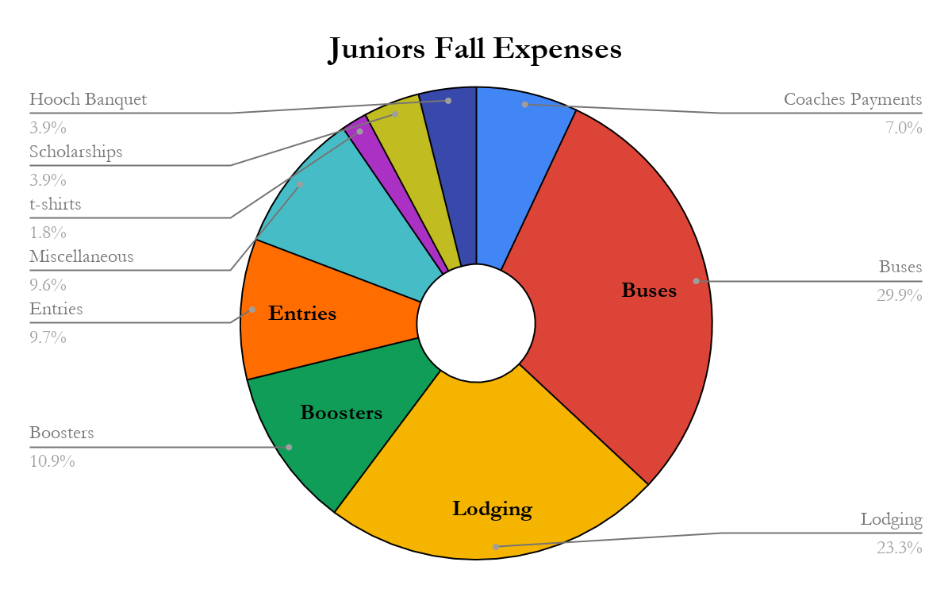
  + Pricing is competitive
    - Median Income in Central Indiana is $43,469-$87,782
      * If assumed an average of $3500 per year for Junior, that represents 4-8% of income
  + Winter Training -
    - $175 for Masters ($200 for non-members) - 47 total - 1 person not paid
    - $275 for Juniors - 49 total - 2 people not paid

**Social Media**

* IRC is active on Facebook and Twitter, Alyssa Poer is communications intern and is making great progress on some internal projects as well as developing our social media strategy
* Facebook:
  + Data from over the past 28 days.
  + 52 Page Views, up 108%
  + 7 new page likes, up 133%
  + 4,082 people reached, up 557%
  + 415 post engagements, up 231%
  + Money spent boosting posts: $36.98 since November 7, 2018.
* Twitter:
  + Data from February:
    - 298 profile visits
    - 4,531 tweet impressions
    - 3 mentions
    - 2 new followers
  + Data from January:
    - 3,417 tweet impressions
    - 151 profile visits
    - 2 mentions
    - lost 3 followers
* Instagram:
  + Data from Feb. 24-Mar. 2
  + 247 actions taken on account
  + 264 profile visits, up 154 from last week
  + 9 website clicks, up 9 from last week
  + 875 accounts reached
  + reach: 875, up 199 from last week
  + 7,150 impressions, up 3,322 from last week

**Outreach**

* Horizons Foundation - new for next summer
  + serves ~50 students, primarily in middle school and primarily at-risk youth
  + 1/week in June and July
* Adaptive Rowing – Talking about this starting earlier next year in order for us to have adaptive events at the summer sprints
* Veterans Administration - I will be meeting with our VA contact about the possibilities for next year
* RowIndy –
  + Working with Erg Ed to implement this.
* Cancer Support Community
  + Meets every Wednesday from 10-11am...received $2500 from Key Bank specifically for this
* Joseph Maley Foundation
  + once a week for 6 weeks in the summer 2019

**Events**

* **Events review**
  + Indy Indoor Championships - February 2nd, 2019 - Broke Even financially even though attendance was down from last year
* **Future Events**
  + Junior Sculling - May 4th and 5th, 2019
  + Big Ten’s - not planning for 2019 but back in 2020
  + NCAA’s - May 29th - June 2nd, 2019
    - Erik Johnson - Chair
    - October 22nd, 2019 was initial site meeting with NCAA
    - working with the Indiana Sports Corp to request infrastructure funding
  + Indy Summer Sprints - June 22nd, 2019
  + Head of the Eagle - October 5th, 2019
* 3rd Annual Audrey Lupton 5K - October 19th, 2019
* **VisitIndy Economic Impact Data**
  + NCAA - $1.1 million
  + Big Ten - $387,000

**Fund Development**

* Michael Browning - has tentatively committed to $10,000/year over the next 5 years...working with Erik on agreement...we have received the initial $10,000
* Mayor - fixing the peninsula (see above)
* Brand New Starting Platforms
  + ISC, NCAA, Parks board, CIB
  + Many individuals from the work of Erik Johnson and Jason MacLean
* Key Bank - $2500 for scholarship funds and $2500 for Cancer Support Community
* Trivia night on February 17th, 2019
  + raised $750 for the boat campaign on that one night
  + planning for another in June or July

**Boathouse Management**

* Emmanuel and I will be working with an ongoing and constantly updating list of things that need to be done at the boathouse...this goes well beyond boat repairs.

|  |  |
| --- | --- |
| **Date:** | 3/11/2019 |
| **To:** | IRC Board |
| **From:** | John Murphy |
| **Subject:** | **IRC March Financial Report** |

All,

Agenda items for March meeting:

* Financial Position
* Full Year 2018 Financial Results
* 2019 Budget
* 990s
* Sports Corp Grant
* Schwab accounts for restricted funds

The cash position as of Friday is

* Club cash: $25,400
* Capital account: $5476
* Boosters: $5170
* Restricted: $29053 ($65,653).

The $101,700 cash position is up approximately $30,000 since the beginning 2019. $36,600 of this is the Sports Corp grant down payment and the amount is completely earmarked for new starting docks. The usable balance of $65,044 is down a bit from the January balance of $73,000. The $65,000 is a significant improvement from the March 2018 balance of $36000. The Operating Cash account balance is down due to the transfer of funds from it to correct the balances in the Restricted accounts.

Full year financials indicate $41,892 net profit for 2018. This beats the 2018 budget Net Income projection by $30,000. I will publish a line by line budget-to-actual for 2018 as soon as I get the reconciliation done. The dues increase has helped significantly, as has a more successful fund raising program.

The 2019 Budget was sent out for approval last week. Several have approved, let me know if you did not get the email.

We should be in a position to send the 990 data to Pile by the end of the month. We may or may not meet the April 15 filing date, but should be able to file soon after.

A note on the Sports Corp Grant: The Sports Corp Grant will skew Net numbers on the Income Statements for the next several years. I will be reporting operational income , net before accounting for the Grant, as well as, numbers including the Grant. This year we will show a large total profit. Until we totally depreciate the new docks over the next 15 years, we will be showing less profit than we are actually making over these 15 years, due to the large depreciation expense the docs will represent.

I have information on setting up two accounts at Schwab for the restricted funds accounts. I need to chat with the Finance Committee on when to proceed. To actually set up an endowment that would be managed by Schwab, we need to get to a $250,000 balance in all of our accounts combined.

Respectfully,

John Murphy

Treasurer

|  |  |
| --- | --- |
| **Date:** | 1/14/2019 |
| **To:** | IRC Board |
| **From:** | John Murphy |
| **Subject:** | **IRC January Financial Statements** |

All,

Agenda items for September meeting:

* Financial Position
* Second Half and Full Year 2018 Financial Results
* 2019 Budget

The cash position as of Sunday is

* Club cash: $35,648
* Capital account: $10,476
* Boosters: $5,170
* Restricted: $22,178.

This $73,472 cash position is up $13,000 since the beginning of the fall. Fall revenue and expenses are mostly realized. Increased dues and nice fundraising continue to show their effects.

I will try to present the second half of 2018 results at the meeting. Thanks to Doug for turning preliminary numbers for 2018 around quickly so as to enable review of these vs. budget in 1Q this year. As a reminder, I will be presenting these numbers every 6 months from here on. July and January should be numbers not affected by Dues and Expense timing, like Fall and Spring financial reports would be. The second half of 2018 numbers will be from after the dues hike and other Fall activity.

I will present the budget at the meeting.

Respectfully,

John Murphy

Treasurer

Bank Balances 2019-03-11



Restricted Funds Report

