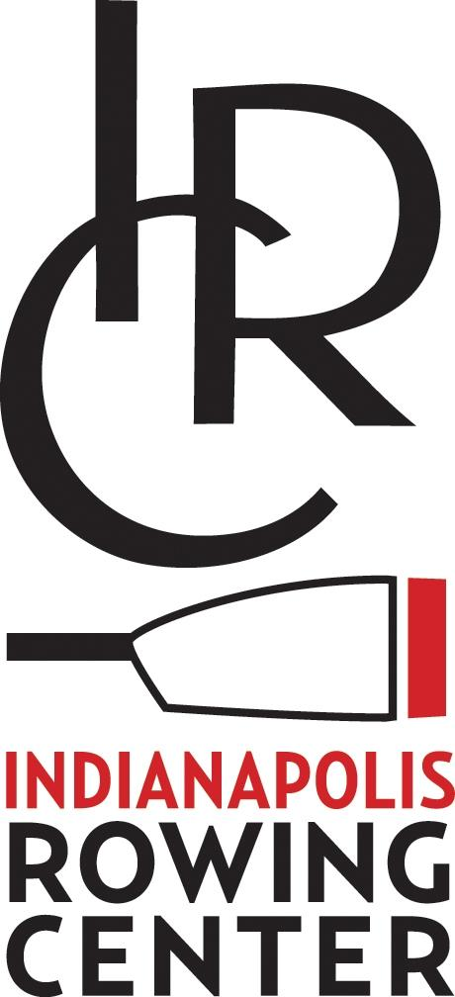

The Indianapolis Rowing Center (IRC) will host the Indy Summer Sprints in Eagle Creek Park, Indianapolis, IN.

REGATTA ADDRESS: 7350 Eagle Beach Drive, Indianapolis, IN 46254
EVENT DATE: Saturday, June 18th, 2022
REGISTRATION DEADLINE: Monday, June 13th, 2022

REGATTA STAFF:
- IRC Director/Event Committee Chair: Angelia Thorpe (Athorpe@indyrowing.org)
- IRC Director of Rowing: Samuel Knauss (samuel.knauss@indyrowing.org)
- IRC Boathouse/Equipment Manager: Willie Black (willie.black@indyrowing.org)
- Chief Referee: Eric Chiang

REGISTRATION/ENTRY FEE:
All registrations must be completed through Regatta Central.

WAIVERS:
- The Indy Summer Sprints is a USRowing registered regatta. All participating clubs must be registered with USRowing.
- Please make sure you have verified that all your athletes have signed a single waiver using the USRowing roster management tool. Rowers can also fill out an IRC waiver, located at www.indyrowing.org. All waivers must be completed and submitted online before the event. No “hard-copy” waivers will be accepted.

LIGHTWEIGHT AND COXSWAIN WEIGH-INS:
There will be no weigh-ins for lightweight rowers or coxswains, but the LOC staff and USRowing Referees reserve the right to weigh any rower entered in a lightweight event if there is any doubt.

COACHES AND COXSWAINS MEETING: The C&C meeting will be held in front of the boathouse at 8:15am. All crews will be responsible for the information delivered at the meeting, regardless of attendance.

SCHEDULE OF EVENTS: The tentative schedule and times for all events are subject to change. We expect racing to start at 9:00am with first events launching at 8:30am. All events will be run on 10-minute centers. A floating start will occur at the 1,000m mark of our 2k course, and competitors will finish their 1,000m race in front of the Finish Tower.

SCRATCHES: Rowers who scratch or withdraw before June 14th are entitled to a full refund. Rowers who scratch on or after June 15th will NOT be subject to a refund.

NOVICE/REC EVENTS: A novice/rec rower shall be defined as any novice rower (first year) or rower who rows for fun and races occasionally. These crews typically practice no more than two to three times a week. These rowers have no intention of competing at Masters Nationals or other highly competitive regattas. A rower who has previously competed only as a coxswain can compete as a novice rower. A coxswain who has previously competed only as a rower can compete as a novice coxswain.

MIXED EVENTS: At least half of the rowers in the boat must be female. For example, in the mixed eight events, you can have 5 women and 3 men, but you cannot have 5 men and 3 women.

ADAPTIVE EVENTS: All rowers entered in adaptive events must have a person who can ride along in a launch and provide support specific to the rower should that become necessary.

HANDICAPPING EVENTS: All events will be handicapped based on USRowing rules, unless all entries in an event are in the same age category.

LAUNCHING: The first call will be 30 minutes prior to the event start, and the 2nd call will be 20 minutes prior to the event start. Launch officials at the launch docks will make every effort to launch boats on time. It is your responsibility to report to the starting line on time, regardless if you hear the race calls or not. A representative must check-in with the dock master before launching for every race.

RACE-DAY TRAFFIC PATTERN: Maps will be posted at the regatta site with the traffic pattern and the pattern will be covered in detail at the C&C Meeting. The traffic pattern is also posted on the IRC Indy Summer Sprints page (Resources --> Policies).

To reach the warm-up area, you must row across the course at the 1500m mark and commence a counter-clockwise movement. Once your race has been called, you must row north past the pontoon at the 1000m mark and then take up position in your assigned lane. There will be a marshal in the warm up pool, and a marshal above the start, to sort crews into their appropriate lane, before their race starts.

When crews finish, you may turn to port and row back to the recovery docks on the outside of the course. You may also turn to starboard and commence a counter-clockwise cool down on the west side of the course. In order to reach the recovery docks, you MUST row to the end of the course and cross to the east side of the course when the area is clear.

HOT SEATING: Hot seating (of equipment or personnel) will be performed at the crew’s risk of missing an event but we recommend at least 30 minutes between events for hot seating to take place. There will be a designated Hot Seating dock.

BOW NUMBERS: The Indianapolis Rowing Center will not provide bow numbers for all teams (these are brand new with the IRC logo on them) so please help us make sure they get back to IRC when you get off the water. Thank you

EQUIPMENT: The Launch Dock Coordinator will be checking bow balls and quick release foot stretchers before crews launch. Boats without these minimum requirements will not be allowed on the water.

AWARDS: Medals will be awarded as results are finalized. Medals awarded to first, second, and third place for all races. Medals may be picked up at the gazebo by the launch dock. Results will be posted at this location as well as at the control commission near the recovery docks. Note that medals will not be mailed to winners. ALL medals must be picked up prior to teams departing the regatta venue.

PARK ENTRY FEE/PARKING REGULATIONS: There is a $6.00 fee for out of county cars to enter Eagle Creek Park ($15 for vans and buses). Park gates will be open at 6:00am. Teams will be given a pass for the tow vehicle to enter the park. All other vehicles (team buses, vans, spectators, rowers, coaches, etc.) will have to pay the park entry fee. Eagle Creek Park is one of the country’s largest city parks and will be open during the regatta. Please follow all posted parking instructions and park rules.

Primary parking for spectators and competitors will be in the parking areas of Eagle Beach Drive and the swimming area.

TEAM TENTS: Team tents are welcome. When you arrive you will be shown the area reserved for tents and grills. The last 250m of the race course is in the swimming area of the park. This fenced in area will be in use by the public. Team tents and spectators will have to set up and watch from the boat storage area/recovery docks, or in the IRC boathouse area.

CONCESSIONS & MERCHANDISE: IRC will provide large coolers of water and Gatorade, but you must bring your own re-fillable water bottle. Alcoholic beverages are not permitted on park property. IRC merchandise will be available for sale during the regatta.

TRASH/RECYCLING: Please bring extra trash bags for your team area. The trash bins can fill up quickly. We will also have a few recycling containers throughout the venue. Please use these to dispose of your plastics.

SECURITY: Eagle Creek Park is a public park. Please be sure to bring your personal valuables with you to your team area, or lock them in the trunk of your car. DO NOT leave valuable items clearly visible in your vehicle (on the seats or dashboard). The gates to Eagle Creek Park are locked from sunset to sunrise. All trailers will be in an area that is gated, locked and enclosed.

WEATHER: It is possible that weather may delay racing. If this is the case the following strategies may be taken to accommodate a shorter racing schedule:
- Cancel small boat events
- Reduce to approximately 500 meters and 5 minute centers
- Regatta canceled

It is also possible that in cases of wind the LOC, along with the chief referee, may make the decision to cancel small boat events in the interest of competitor safety.

Samuel Knauss
Director of Rowing

Thank you! IRC, the LOC, Indy Parks, the City of Indianapolis and Eagle Creek Park staff look forward to the competition!

